A Brief Guide to
Philosophical Issues about Animals

Any discipline which is heavily involved in understanding humans will also be interested in animals - after all, humans are a kind of animal. One of the main questions that philosophers try to understand is whether there are philosophically significant differences between human and non-human animals, as this is key to determining how they should be treated and how they fit into different philosophical theories.
One such philosopher is Pete Singer, who argues that favouring the rights of humans over other animals is an example of speciesism. Often, people justify treating animals differently to humans on the grounds of physical or intellectual differences. Singer argues that this represents a bias and does not provide morally significant reason for treating animals as inferior. For example, most people would think it is wrong to treat a person badly if they look different from us, and as such, we cannot justify treating an animal badly even though they are different from us.
“If possessing a higher degree of intelligence does not entitle one human to use another for his own ends, how can it entitle humans to exploit non-humans?”
- Pete Singer in ‘All Animals are Equal’
This is not to say that Singer believes that animals should be given the same rights as humans – instead he argues that they should be given an equal consideration of interests. This means that only relevant rights need to be considered – for example, voting and marriage rights would be deemed unimportant for most animals. As to what would be a typical interest for most species, the nineteenth century English philosopher Jeremy Bentham takes a lead. He argues, “The question is not, Can they reason?, nor Can they talk? but, Can they suffer?”, suggesting that regardless of the degree of similarity to humans, all animals have the interest of avoiding pain, and thus should be treated in a way that avoids causing it.
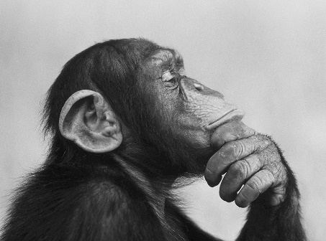
Debate of this kind is important, as it feeds into many other aspects of discussion – most significantly how animals should be treated. In recent years, the ethical issues of using animals for work, food and pleasure have been heavily discussed, leading to the prominence of vegetarianism and veganism. The personhood debate (which informs issues like abortion and euthanasia by questioning which factors are necessary for something to be considered human) is also affected by the status given to non-human animals - for example, raising the question about the difference between euthanasia in humans and the putting down of pets.
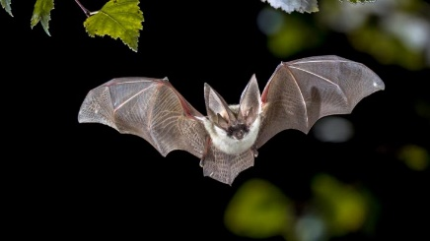
Another philosophical issue about animals relates more closely to debate between materialism and dualism – do animals have minds? Historically, thinkers like Aristotle and Descartes argued that this was not the case, suggesting that whilst humans act on intelligence and reason, animals are only motivated by instinct. This was particularly represented in Cartesian dualism, where it was believed that the mind was the soul and that animals did not have a soul – thus reinforcing the view that animals do not have minds. However, this view is challenged by the materialist view that the mind is the brain – meaning that all the animals which have brains also have minds. This is backed up by research which show that animals do think – for example solving problems in similar ways to humans, communicating with one another and understanding complex situations – suggesting that animals do have minds
Thomas Nagel furthers this discussion by focusing on consciousness. He defines consciousness as there being, “something that it is like for the organism to be itself”. Nagel argues that many species do have this conscious experience and that these experiences have a subjective quality which cannot be accessed by other organisms. To illustrate this, he gives the example of a bat – whilst bats are assumed to have consciousness, they have evolved to be extremely different to us, for example navigating about through echolocation. Nagel highlights how difficult – verging on impossible – it is to imagine this, illustrating that whilst we may be able to imagine being a bat, we cannot understand what it is like to have their viewpoint, as we our limited by our own experiences. For Nagel, this shows that many different species have conscious experiences. Some philosophers have also drawn from this conclusion to back up the idea that animal have minds, as the presence of consciousness suggests that their experiences cannot be merely materialistic.

Animal Rights
Singer, Peter, ‘All Animals are Equal’ in Animal Liberation [Accessed: https://www.uvm.edu/rsenr/wfb175/singer.pdf ]
Singer, Peter, ‘Taking Life: Animals’ in Practical Ethics (Cambridge University Press: Cambridge, 2017) p110-p136 [Accessed: http://www.stafforini.com/docs/Singer%20-%20Practical%20ethics.pdf]
Animal Minds
Nagel, Thomas, ‘What Is It Like to Be a Bat?’ in The Philosophical Review, Vol. 83, No. 4 (Duke University Press: North Carolina, 1974), https://warwick.ac.uk/fac/cross_fac/iatl/study/ugmodules/humananimalstudies/lectures/32/nagel_bat.pdf
Andrews, Kristin, The Animal Mind, (Routledge: Oxfordshire, 2014) https://www.researchgate.net/publication/263066889_The_Animal_Mind

