A Brief Guide to Philosophy of Mind
Questions about how the mind and body are linked have been asked for thousands of years, with philosophers, theologians and scientists falling on different sides of the debate between dualism and materialism. As well as helping philosophers to understand how the mind works, the debate also feeds into other questions: What makes someone conscious? What constitutes identity? Can there be life after death?
Broadly, dualism is the view that the mind exists independently of the body. According to dualists, this means that the mind is not just the brain, or anything solely physical. In the 17th Century, Rene Descartes was particularly influential in the development of dualism, suggesting that the mind is something which does not depend on the existence of anything else. This ‘mind’ is characterized by thought – something which Descartes argues for in his evil demon thought experiment, whereby the possibility of a demon distorting everything in the physical world causes him doubt everything, except for the fact that there must be someone doing the doubting. This led to his famous conclusion: “Cogito ergo sum”, I think therefore I am.
Nevertheless, dualism is a problematic viewpoint to take. Those defending it must explain how the mind fits into the causal structure of the world (as, if the mind impacts the world but is distinct and immaterial, there would be frequent challenges to the laws of physics). Dualism is also challenged by evolutionary theory, as it must explain how something non-developmental could come into the world specifically for humans. It must also prove to be a better explanation of how the world works than its main opposition, materialism.
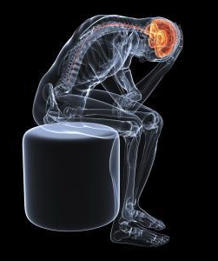
Materialism is the view that the mind and body are not distinct entities. According to materialism, thinking and feeling are just activities or features of the brain. Although there have been defenders of materialism at least since ancient Greece, the view became more popular during the 1950s, with advances in science. As a result, many materialists would argue that their view is the best explanation for the extensive correlation between mental events and brain activity, for example the relationship between damage to specific areas of the brain and reductions in mental activity.
However, can the identity statement that the mind identical to the brain be accepted? This would mean that the mind and the brain must have identical properties and natures. Despite the scientific evidence backing up this view, many people would argue that humans have some experiences which cannot merely be reduced to brain activity. One example of this is qualia; the subjective qualities of what something is like, so the expereince that you have. This is demonstrated in Frank Jackson’s thought experiment, known as ‘Mary’s Room’, whereby scientist Mary has carried out extensive research into the colour red, even though she has been raised in a completely black and white environment. This means that whilst she knows everything about the properties of redness, and what effects seeing it will have, she hasn’t had these experiences for herself. Jackson claims that Mary will learn something new on seeing red, suggesting that brain states are not the same as sensations (qualia). As such, it seems that experience is different from just the firing of neurons, as captured by Jackson:
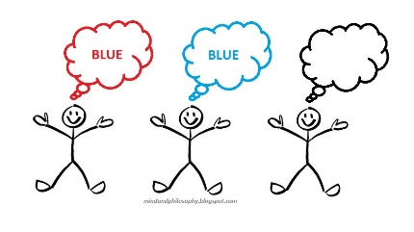
“Tell me everything physical there is to tell about what is going on in a living brain … you won’t have told me about the hurtfulness of pains, the itchiness of itches, pangs of jealousy”
Another way to visualize this issue is by imagining whether there could be something physically identical to us, but lacking consciousness – as demonstrated in Chalmer’s ‘Zombie Problem’.
In philosophy of mind, questions like these provide opposition for materialism. They suggest that there is something more to humans than the brain alone, providing examples where the limits of scientific knowledge are stretched. However, there is no easy resolution to the debate between materialism and dualism, and there are many arguments and counterarguments surrounding this. Below is a selection of relevant papers which could help you make up your *mind*.

In favour of Dualism
Chalmers, David, The Conscious Mind, 1995, http://ghiraldelli.pro.br/wp-content/uploads/The-Conscious-Mind-Chalmers-David.pdf - For the ‘Zombie Problem’, see chapter 3.1
Descartes, Rene, Meditations in First Philosophy’ in The Philosophical Works of Descartes, translated by Elizabeth Haldane, (Cambridge University Press: Cambridge, 1911). [Accessed from Internet Encyclopedia of Philosophy, http://selfpace.uconn.edu/class/percep/DescartesMeditations.pdf ]
Jackson, Frank, 1982, ‘Epiphenomenal Qualia’ in The Philosophical Quarterly 32, https://www.sfu.ca/~jillmc/JacksonfromJStore.pdf
Jackson, F., 1986, “What Mary Didn't Know” in Journal of Philosophy 83, https://pdfs.semanticscholar.org/d5f0/b1d40bd79be8ec2419e824771300ac5db204.pdf

In favour of Materialism

Ryle, Gilbert, ‘Descartes Myth’ in The Concept of Mind, http://faculty.arts.ubc.ca/maydede/mind/Ryle_DescartesMyth.pdf
Correspondence between Descartes and Princess Elizabeth 1643-1649 [Accessed from Early Modern Texts, https://www.earlymoderntexts.com/assets/pdfs/descartes1643.pdf ]

Levine, Joseph, 1983, ‘Materialism and Qualia: The Explanatory Gap’ in Pacific Philosophical Quarterly, Volume 64, Issue 4 [Accessed from the Wiley Online Library: https://onlinelibrary.wiley.com/doi/abs/10.1111/j.1468-0114.1983.tb00207.x ]
Dennet, Daniel, Consciousness Explained, (Back Bay Books: New York, 1991) https://zodml.org/sites/default/files/%5BDaniel_C._Dennett%5D_Consciousness_Explained.pdf

