A Brief Guide to Bird Intelligence

While primate intelligence has been the subject of much investigation, recent research has shown that great apes are not the only animals to possess powerful minds. Birds such as corvids (a genus which includes crows, ravens, rooks, and magpies) can apply logical reasoning to solve complex problems, use tools, and understand their positions within social hierarchies. Parrots, can mimic a variety of sounds, including human speech, demonstrating advanced imitation-based learning. This guide will outline some of the research conducted into the subject of bird intelligence, as well as how the cognitive capabilities of birds can inform our perspective on the potential abilities of non-primates.

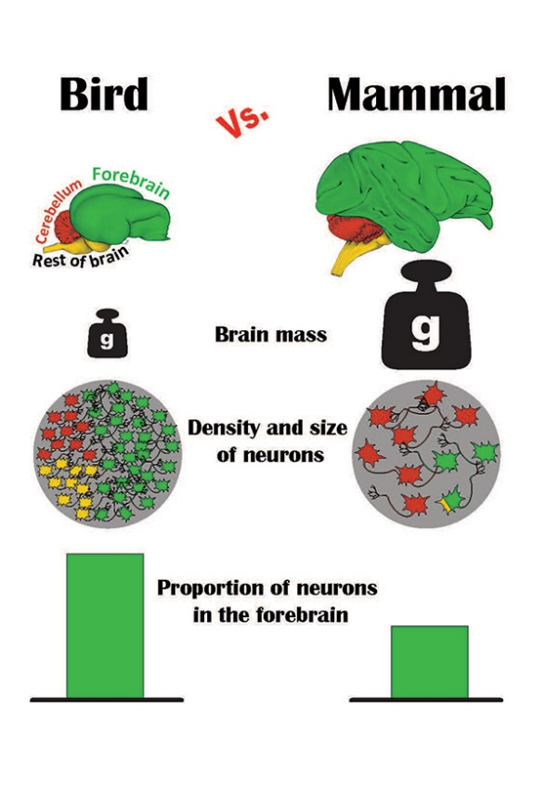
Many of us have heard the phrase ‘bird brained’, which is often used to describe someone of less-than-average intelligence. It is true that bird brains are small, much smaller than those of primates, and that they are organised differently. However, the individual neurons in some bird brains are more densely packed together than primate neurons, meaning that their brains contain more neural material per cubic millimetre. They also contain more neurons in their forebrains, which specialise in things like problem solving, planning, and advanced reasoning. This explains why some types of birds can engage in very complex behaviours while still having small brains. Thus, intelligence may not be about absolute brain size, but also about a brain’s density and connectivity.
So, given that some bird species have brains capable of high-level cognition, what can they actually do?
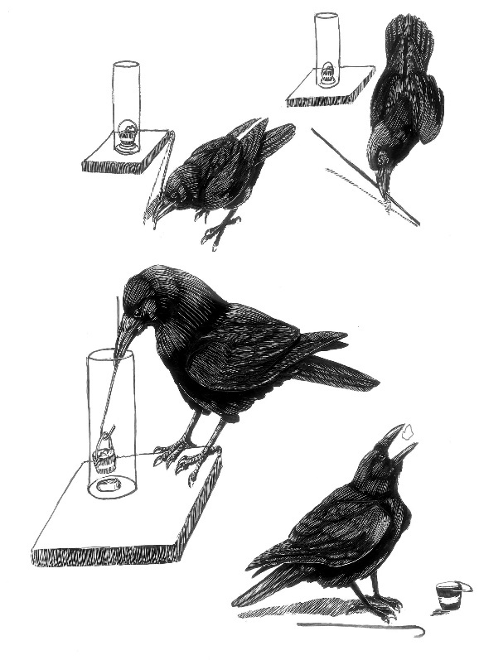

One of the things we may think about in considering what makes primates intelligent is our ability to make and use tools. Humans use tools to complete thousands of different activities each day. Crow species found on the Pacific island of New Caledonia have also been found to engineer their own tools in order to extract insects from small holes in trees. By twisting twigs into hooks, and modifying them as needed, New Caledonian crows demonstrate the ability to innovate and use the materials around them to solve problems.
British and American crows also show remarkable levels of intelligence, which allows them to flourish in human-dominated landscapes. In 2010, a researcher named John Marzluff found that crows can even recognise individual human faces and tell other crows which humans should be avoided. In his experiment, Marzluff and two of his students wore rubber caveman masks and walked through their university campus in Seattle, trapping a few crows for a brief period of time. After they had released the crows, the researchers walked through the campus again to see how members of the local group of crows would react. Unsurprisingly, many crows proceeded to loudly scold them, even when they wore hats to partially conceal the masks. When the researchers returned with the masks two years later, however, something fascinating happened—even more crows scolded them, indicating that during that period of time, the crows that had been trapped initially warned others of the dangerous cavemen. This shows us that crows can not only identify individual human faces, but also remember which humans are untrustworthy and communicate that information to crows who had not witnessed the initial incident. This experiment shows that crows, while being relatively common, show an uncommon aptitude when it comes to facial memory and social communication.

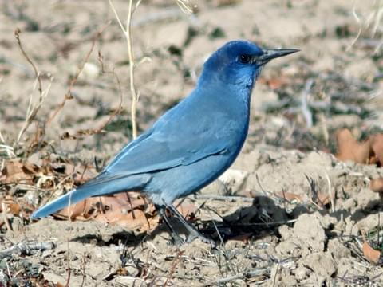
A 2004 study also found that pinyon jays, a corvid species found in North America, can use logic to judge where they lie in a social hierarchy. These birds congregate in social groups containing hundreds of individuals, so it is useful to be able to judge one’s position relative to other jays. To do this, pinyon jays employ advanced cognitive processes to logically deduce their standings, using an abstract mental process called transitive inference. Humans use similar processes to engage in logical reasoning and solve mathematical problems, something we used to think was unique to our species. Birds’ brains may be small, but they can store tons of information, using it to navigate their way through a world defined by social roles and experiences.

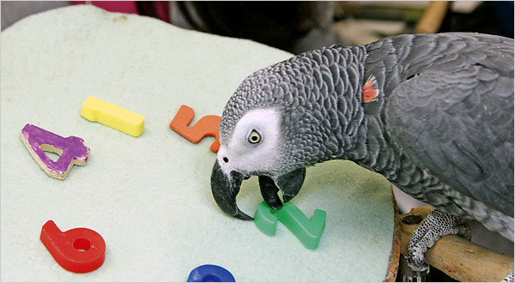
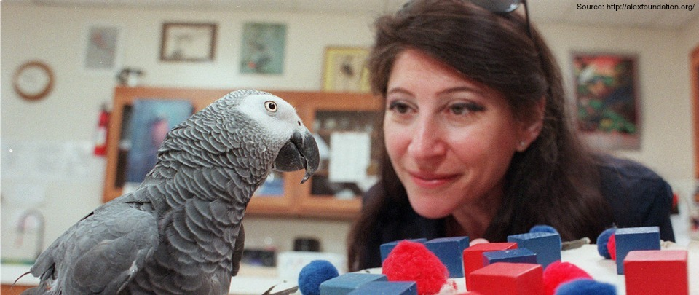
Parrots also demonstrate high levels of intelligence. Alex, an African Grey Parrot and the subject of a thirty-year study in Harvard’s Pepperberg Lab, showed just how capable birds are of learning through imitation, communicating, and using tools. At five years of age, Alex was able to identify the functional use of about 40 different English words—meaning that Alex could identify objects presented by his human caretakers by actually saying what they were. Amazingly, he also learned the meaning of words like ‘no’, often saying it if he did not wish to be handled by his carer, or if he was unsatisfied with what he thought was an insufficiently-sized piece of food. By the end of his life, Alex also learned how to string together basic combinations of words in order to communicate in higher detail. For instance, he began to identify green clothing pegs by saying “green peg wood”, using adjectives in his speech. While this does not reflect the use of grammar, Alex’s abilities greatly changed the ways in which we think about avian intelligence. Interestingly, Alex is also the first non-human animal we know to have asked an existential question after being placed in front of a mirror: “What colour [am I]?”.

Birds like corvids and parrots show us that intelligence is expressed across the animal kingdom, and that the origins of intelligence vary across species. We share a close common ancestor with other primates, but this is not the case with birds—their intelligence developed along different evolutionary lines, supported by a different neurological structure in a different ecological context. There is much to still be learned about bird intelligence, but one thing is certain: the more we discover about their cognitive abilities, the more we can appreciate the diversity and capacity of animal minds.

