A Brief Guide to Language
Over the years, linguists, anthropologists, and psychologists have debated the origins and nature of language, as well as whether it is a uniquely human trait. We know that other animals can communicate—anyone who has a pet knows that animals have their own ways of indicating certain things to us and each other. But does this count as language? Or is language something that humans have in addition to other forms of communication? In this guide, we will explore the research behind the fascinating field of linguistic psychology and strive to answer some rather difficult questions: what is language, and is it the thing which sets humans apart from other members of the animal kingdom?

Before we delve into some theories of language, let’s consider the similarities and differences between how humans and other great apes communicate.

When we communicate, we use a mixture of verbal and nonverbal signals. Humans speak, write, gesticulate, and produce different facial expressions to convey a variety of things. Over millions of years, humans have evolved physical traits which allow us to express ourselves in these ways.

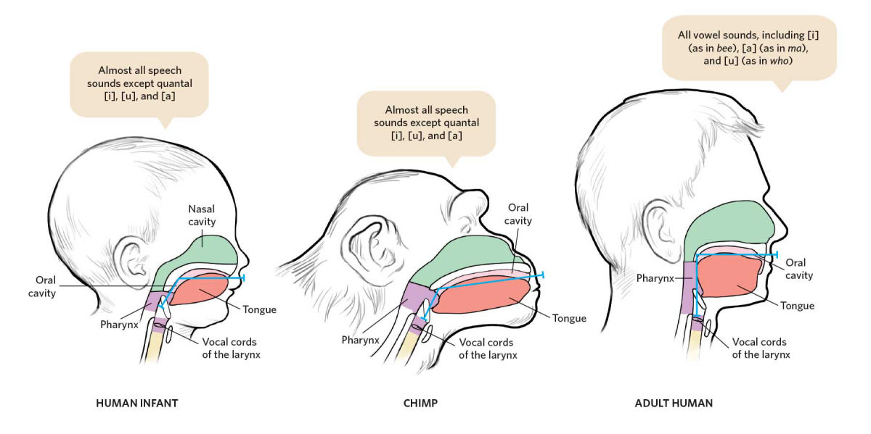
Figure 1: The differences in facial structure between human babies, chimps, and human adults. By adulthood, humans can produce a wide range of vocalisations.

Our ability to speak, for instance, is deeply rooted in how our heads and throats evolved to accommodate the anatomical features necessary for language. Speaking likely gave our ancestors an evolutionary edge, as it is an extraordinarily rich way of sharing information. Those of our distant ancestors who could not engage in complex speech were likely not as successful as as their more linguistically-apt peers. Thus, over time, having the mechanisms for speech became mainstream in our species. Note the differences between human babies, human adults, and chimps in the above diagram. While a chimp’s oral cavity is narrow with a short pharynx, the human’s oral cavity is tall, and his pharynx is longer. This allows humans to make a wider range of sounds. And, though this short guide will not go into too much detail about this, our brains have also evolved to interpret the spoken and written word.
But speaking isn’t the only way we communicate. Though bodily gestures differ greatly between cultures, they are used by all humans. Let’s take a look at some of them:
Figure 2: Waving, using facial expressions, and gesturing with our fingers helps us communicate.
Comparative psychologists have found that chimps also use a multitude of gestures to communicate with one another. This research is discussed in What Kind of Mind? Lesson 4. Chimps lift their legs, shake trees, and stomp to make those around them aware of their needs and intentions. Researchers at the University of St Andrews have been involved in decoding the subtle behaviours of great apes, creating a catalogue of chimp gestures called the ‘Great Ape Dictionary’.
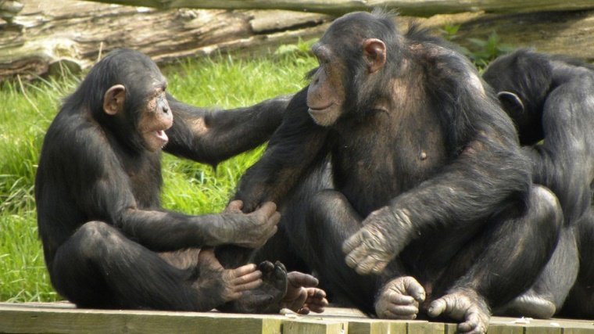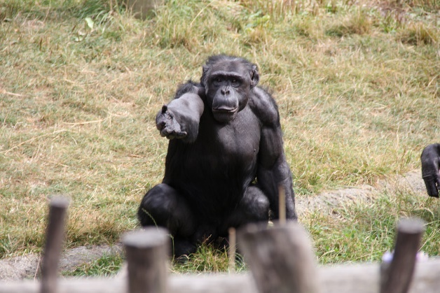
Figure 3: Though they cannot speak like us, chimps certainly demonstrate complex forms of communication.
But the question still remains: does chimp communication count as language? Some linguists, such as Noam Chomsky, believe that language is an exclusively human phenomenon. He argues that humans possess a neural ‘language acquisition device’, which allows us to develop grammar, a core facet of language. While comparative psychologists believe that chimps can combine their gestures to communicate complex messages, human language may be very different—the grammar (i.e., the order, spelling, and punctuation of words) matters. Consider the meaning that even one comma can add to a sentence:
“Let’s eat, grandma.”
versus
“Let’s eat grandma.” (yikes!)
If we are considering language to be a complex grammatical process, then it is unlikely that other animals demonstrate language at all, or a language as complex as that of humans. Grammars are a universal component of all human languages, and it is grammar that allows us to speak about virtually anything with plenty of nuance and elaboration. Thus, we can think of language, at least by definition, as a uniquely human trait. Even languages which are conveyed through movement of one’s body, such as American Sign Language, rely upon the use of grammatical structures as complex as those of verbal languages.
Philosophers also strive to answer the question ‘what is language?’ in different ways. Ludwig Wittgenstein, a philosopher whose work became prominent in the earlier half of the twentieth century, states that the meaning of words is best understood as how they are used in a particular linguistic context. He also argued that our ideas are inherently limited by the languages we use, and that even our thoughts function along the contextual lines of language. In other words, our minds are bound to the way that we use words and grammar to communicate ideas to other people. In psychology, the Sapir-Whorf Hypothesis falls in line with Wittgenstein’s view. According to these researchers, a language greatly determines the cultural norms, ideological outlooks, and behaviours of those who speak it. In fact, language can even alter our perceptions! Here is an example:
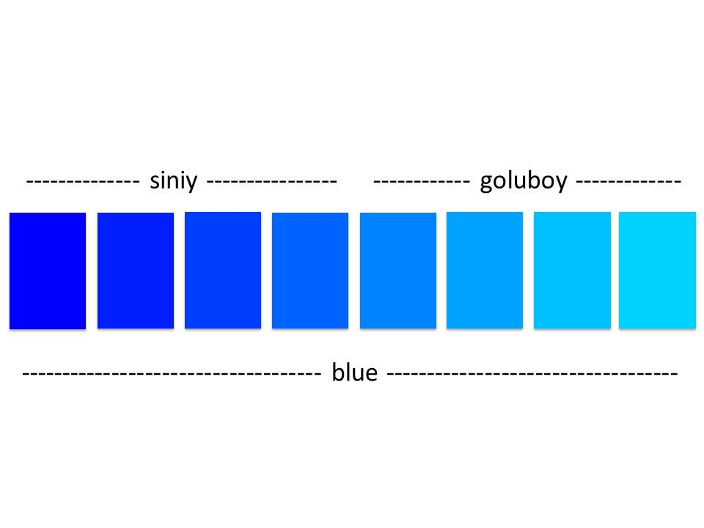
Russian speakers can distinguish between shades of blue much more easily than English speakers. This is not because Russian speakers have better vision; rather, they have two different words for the colour ‘blue’. Siniy refers to darker shades of blue, whereas goluboy refers to lighter shades. From a young age, Russian-speaking children learn to distinguish between the two much in the same way that English-speaking children learn the difference between the colours red and yellow. Siniy and goluboy are treated as entirely separate, whereas in English, they are both just variations on the same colour. Can you tell the difference between the two tiles in the middle of the row? Many English speakers cannot. However, studies show that most Russians can—and this is because human brains are wired to process language and adapt according to our linguistic environments. We are truly built to use language. Whether other animals are, too, is still debated among academics in psychology and philosophy.
Thus, researchers continue to strive to answer the question of whether human language just a particularly complex form of communication, of which we can see simpler forms among animals, or an evolutionary invention that only humans have.

