A Brief Guide to Brains
There exists a great deal of information out there relating to the study of the human brain—and sometimes, when you are trying to piece all of this information together, it can be difficult to know where to start. Our hope is that this guide will help you begin to navigate neuroscience: a fascinating field of research that can greatly enhance our understanding of our evolution as a species, our cognitive abilities, and the things which make us human.

One important thing to note is how much our brains have changed over the course of evolutionary history. Take a look at the diagram below:

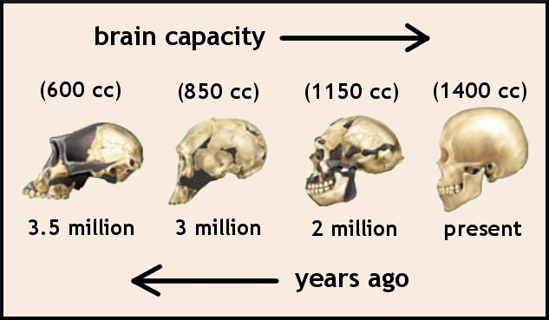
In just 3.5 million years (a very small amount of time in evolutionary terms; life on Earth is estimated to have begun up to four billion years ago!) the size of the human brain has more than doubled. While brain size does not necessarily correlate with processing power across all species, this has a lot of implications for how humans behave and think. Our incredibly complex brains allow us to perform all kinds of different tasks, such as solve complicated problems, produce language, and commit things we have learned to our memories. We may take these things for granted—after all, the great majority of us can read, write, and speak by the time that we are adults. But these are actually very challenging tasks that recruit many parts of your brain at once, and you have your evolutionary history to thank for your abilities.

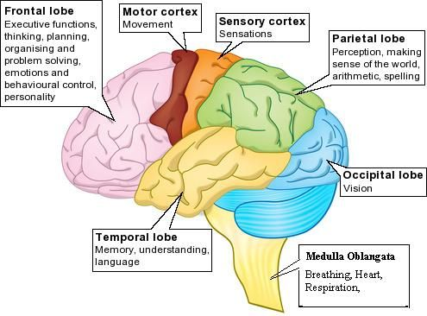
Though neuroscience is a relatively new scientific field, researchers have identified different parts of the brain that are specialised for different cognitive tasks. For instance, the occipital lobe in the back of your brain mainly processes visual information from your eyes. Two bands that go across your brain, the motor and sensory cortices, coordinate your movements and take in information from your sense of touch. However, even though there exist different sections of the human brain, they all work together to produce your conscious and sensory experience.

Animals which are closely related to us evolutionarily, such as chimpanzees and bonobos, have brains which are similar to ours. In fact, we share about 98% of our DNA with these primate cousins! Our brains are larger and more complex than theirs, but we still have much in common with these animals. Both humans and some species of non-human primates use tools, solve problems, interact with one another in complex social settings, and even develop forms of culture.

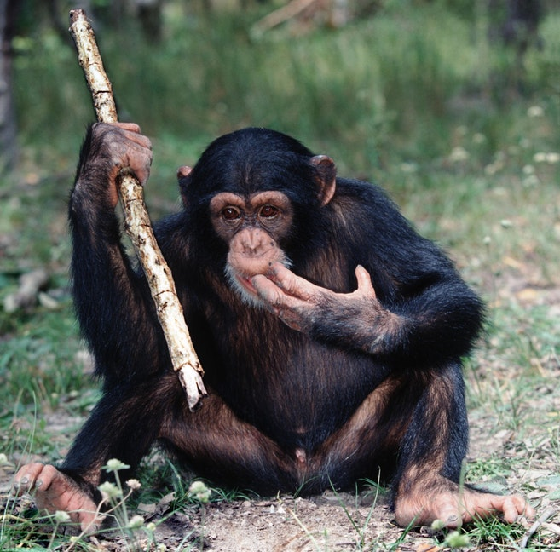
Tool use is common among chimpanzees who, for example, use primitive anvils and hammers to extract nuts from hard shells. Likewise, humans use tools for all kinds of things.

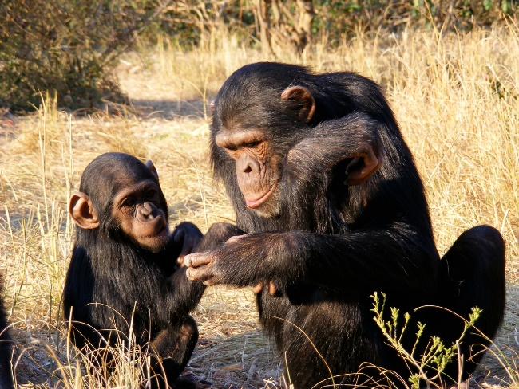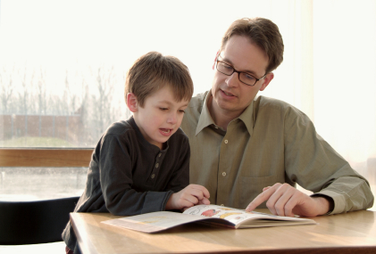
Both humans and chimps learn socially, usually from people within our families and older members of our communities. Chimpanzee and human children rely on this type of learning, which prepares them for the challenges of adult life.

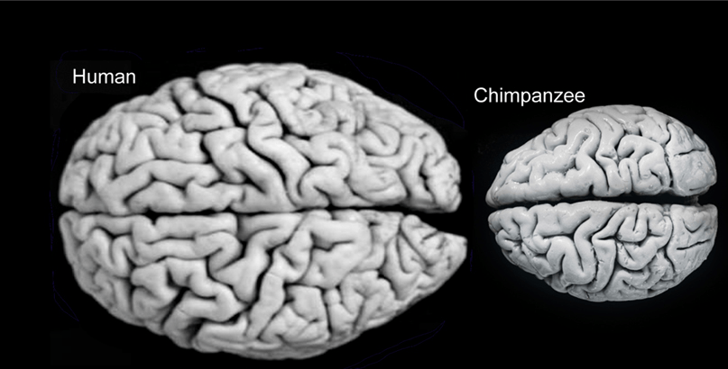
Human brains are much larger than chimp brains, but they are organised in a way that is very similar—this is due to our evolutionary relatedness (and chimpanzee brains are still rather big compared to those of other animals, like dogs). Thus, our minds likely work in similar ways, and by looking at chimp behaviour, we can gain a bit of insight into our own. In addition, chimp brains can give us information about the brains of the common ancestor we shared with them millions of years ago.

